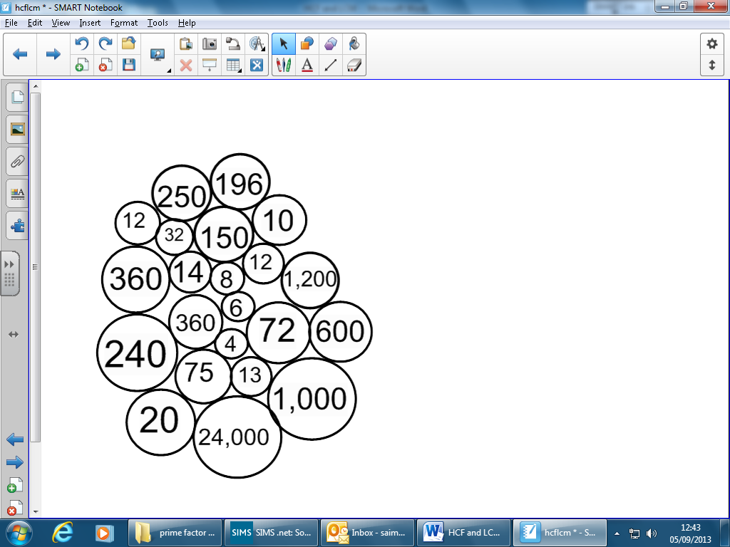**HCF and LCM**

For these sets of numbers, find the HCF and LCM. Colour your answers in from the bubbles on the right. Do your factor trees and Venn diagrams **in your books**. Watch out, there are a few red herrings!

|  |  |  |
| --- | --- | --- |
|  | HCF | LCM |
| a) 120 and 36 |  |  |
| b) 150 and 75 |  |  |
| c) 250 and 40 |  |  |
| d) 98 and 28 |  |  |
| e) 72 and 30 |  |  |
| f) 72, 24 and 12 |  |  |
| g) 8, 80 and 120 |  |  |
| h) 30, 96 and 150 |  |  |

**HCF and LCM**

For these sets of numbers, find the HCF and LCM. Colour your answers in from the bubbles on the right. Do your factor trees and Venn diagrams **in your books**. Watch out, there are a few red herrings!

|  |  |  |
| --- | --- | --- |
|  | HCF | LCM |
| a) 120 and 36 |  |  |
| b) 150 and 75 |  |  |
| c) 250 and 40 |  |  |
| d) 98 and 28 |  |  |
| e) 72 and 30 |  |  |
| f) 72, 24 and 12 |  |  |
| g) 8, 80 and 120 |  |  |
| h) 30, 96 and 150 |  |  |